Functional Design Document

EPIC # 48648 - Feature ID - 52316 - Status bar for Workflow App's Data Grid

Table of Contents

EPIC # 48648 - Feature ID - 52316 - Status bar for Workflow App's Data Grid 3

Current Challenge: 3

Impact of Not Implementing: 3

Key Requirements and Packaging: 3

User Story 1: Status Bar Layout 4

Mock Up: Status Bar Layout 4

User Story 2: Current Page and traversing through pages 5

Mock Up: 5

Conditions: 5

Acceptance Criteria: 6

User Story 3: Changing Page Size 7

Mock Up: 7

Conditions: 7

Acceptance Criteria: 8

User Story 4: Filter Applied 9

Mock Up: 9

Conditions: 9

Acceptance Criteria: 10

User Story 5: Columns Hidden 11

Mock Up: 11

Conditions: 11

Acceptance Criteria: 12

User Story 6: Dynamic status of the Workflow Items 13

Mock Up: 13

Conditions: 13

Acceptance Criteria: 14

User Story 7: Error Notification 15

Mock Up: 15

Conditions: 15

Acceptance Criteria: 16

User Story 8: Current of Total Pages & Total Items 17

Mock Up: 17

Conditions: 17

Acceptance Criteria: 18

# EPIC # 48648 - Feature ID - 52316 - Status bar for Workflow App's Data Grid

*As a Workflow App user, I would like to know the information of my current settings and dynamic information on the operations that I am performing. This can be achieved with the help of a Status at the bottom of the Workflow App which will consists of the information like the current page size, total # of workflow Items, current page that I am on, if filters are applied, if there are any columns hidden, status of the raised workflow events or moving items to another workflow or setting steps of the workflow items, information on in case if any of the Workflow events failed.*

### Current Challenge:

[Epic Current Challenge]

### Impact of Not Implementing:

**Externally:** [Epic Impact of not implementing externally]

**Internally:** [Epic Impact of not implementing internally].

### Key Requirements and Packaging:

[Epic Key Requirements and Packaging]

# User Story 1: Status Bar Layout

*As a workflow user I would like to have the status bar containing information as shown in the mock up.*

### Mock Up: Status Bar Layout

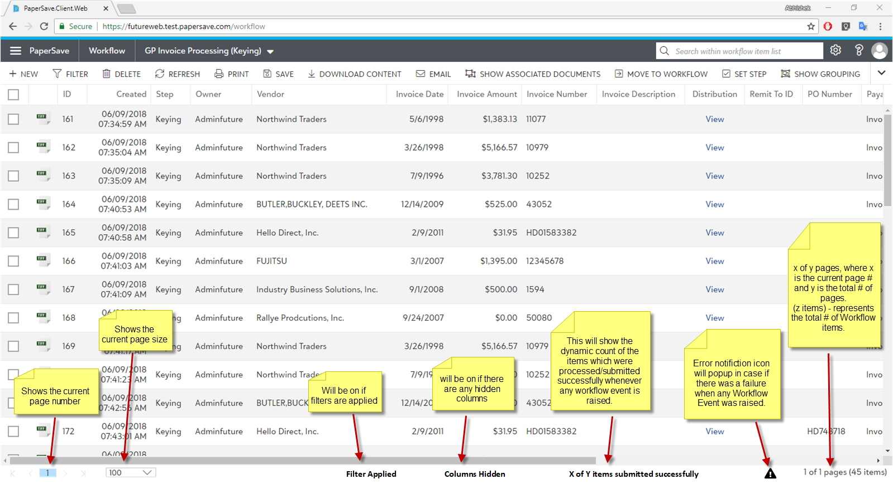

# User Story 2: Current Page and traversing through pages

*As a workflow user I would like to know the current page of the Workflow App I am on and should have the ability to traverse to any other valid page.*

### Mock Up:

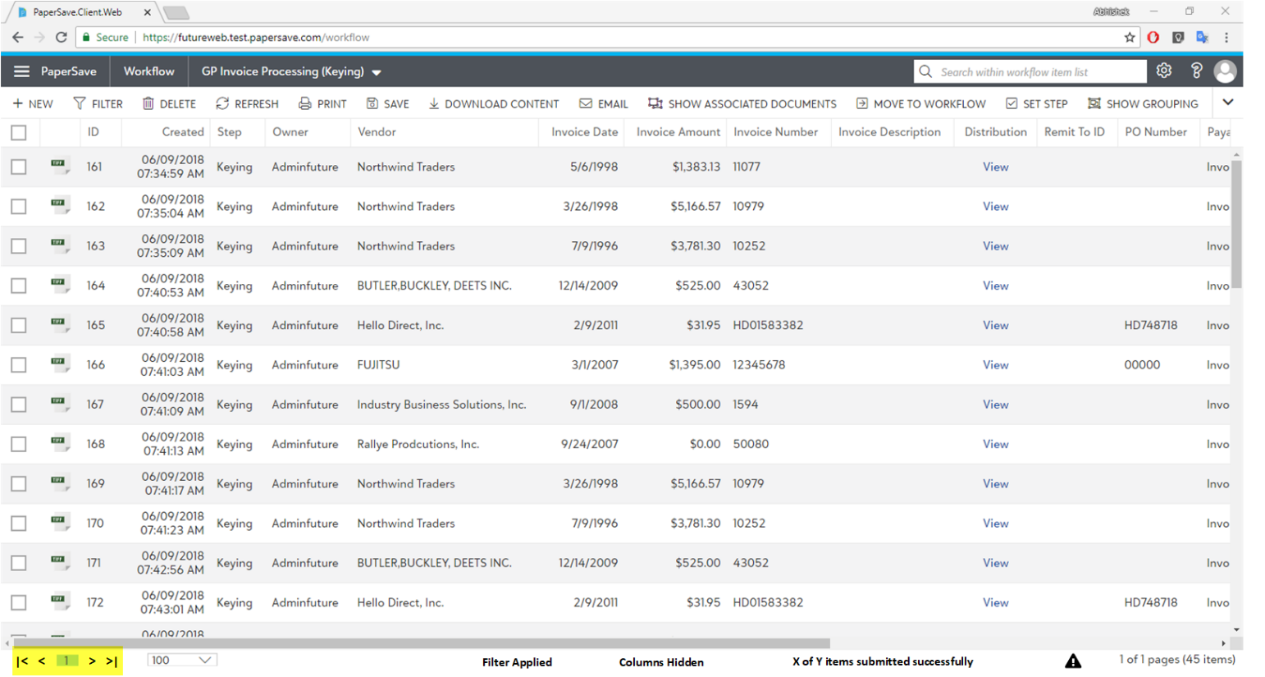

### Conditions:

#### Condition 1: Displaying the current page

* *Here,*  *highlighted number represents the current page number the user is on.*

#### Condition 2: Traversing the page number using the textbox.

* *User should be able to type in valid number (within the total # of pages available), hit the “Enter” key and should be moved to that specific page, and it should be displaying the Workflow Items related to that particular page.*

#### Condition 3: Traversing the page number using the buttons.

* *Clicking on the “****>****” button should take the user to the next available page and it should load the Workflow items related to that page.*
  + *If the user is already on the last page, then the “****>****” should remain as disable.*
* *Clicking on the “****>|****” button should take the user to last page in the list and it should load the Workflow items related to that page.*
  + *If the user is already on the last page, then the “****>|****” should remain as disable.*
* *Clicking on the “****<****” button should take the user to the previous available page and it should load the Workflow items related to that page.*
  + *If the user is already on the first page, then the “****<****” should remain as disable.*
* *Clicking on the “****|<****” button should take the user to first page in the list and it should load the Workflow items related to that page.*
  + *If the user is already on the first page, then the “****|<****” should remain as disable.*

### Acceptance Criteria:

#### Acceptance Criteria 1: Verifying Conditions

*Verify all the conditions mentioned above. (Condition 1 to 3)*

# User Story 3: Changing Page Size

*As a workflow user I would like to have facility to change the number of items displayed per page.*

### Mock Up:

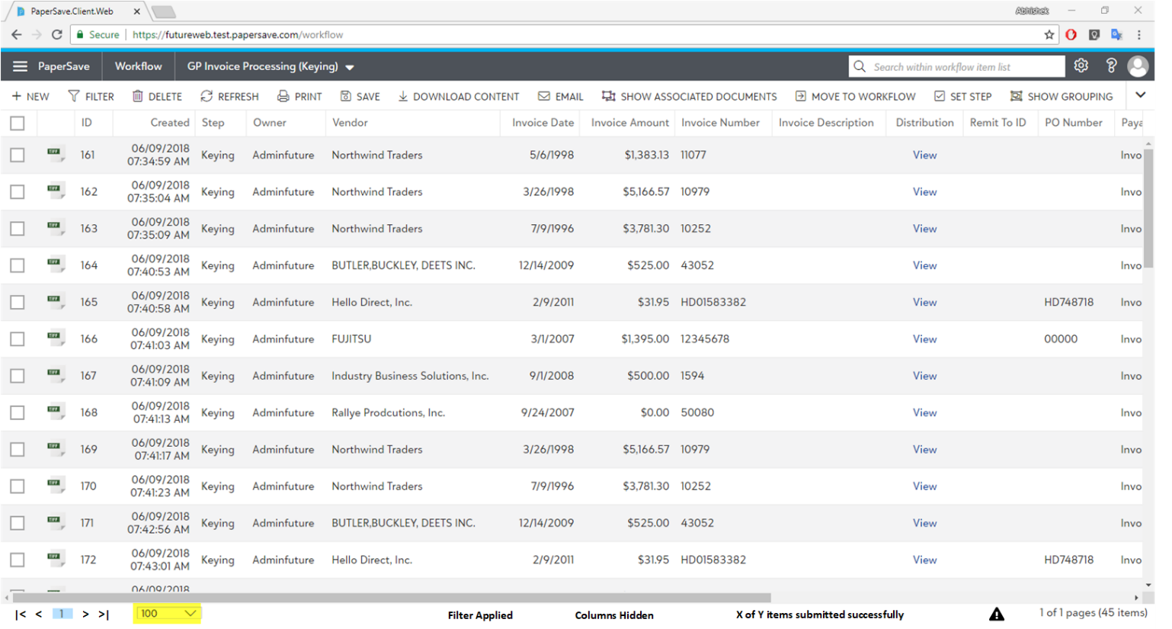

### Conditions:

#### Condition 1: Displaying the current page size

* *Here the highlighted number in the above mock up represents the current page size.*
* *Total number of items displayed per page should be based on this number.*

#### Condition 2: Changing current page size.

* *Upon clicking on the page size drop down list, it displays the list of the other page sizes available as shown below:*

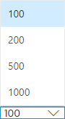

* *Once the user selects any value than the current, then it should display the number of items per page as per the new selection.*

### Acceptance Criteria:

#### Acceptance Criteria 1: Verifying Conditions

*Verify all the conditions mentioned above. (Condition 1 to 2)*

# User Story 4: Filter Applied

*As a workflow user I would like to know if the current set of workflow items being displayed are based on some filters or not.*

### Mock Up:

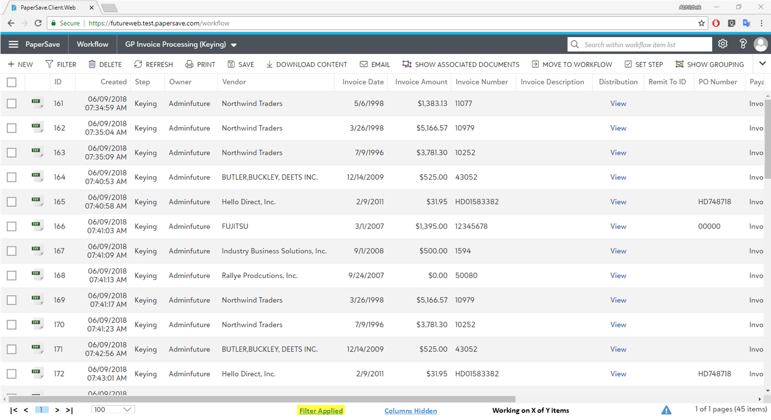

### Conditions:

#### Condition 1: Displaying “Filter Applied” in the status bar

* *If the user has applied any kind of filters on workflow items, then it should display the “***Filter Applied***” label in the status bar.*
  + *The text in the label should look like a hyperlink as shown in the mock up.*
* *In case, if the user clears all the filters, then the “Filter Applied” label should get disappear.*

#### Condition 2: Clicking on the “Filter Applied” label

* *When the user clicks on the “***Filter Applied***” label (which looks like a hyperlink), then it should open a modal dialog box showing the textual representation of the current filters applied as shown below:*



#### Condition 3: Edit button on the Filters dialog box

* *When the user clicks on the “Edit” button, then it should open the filter form and should the Filters dialog box.*
* *In the filter form if the user edits the filters and upon clicking on the apply filters then it should get reflected by showing the filtered workflow items.*
  + *It should keep the “Filter Applied” label as it is in the status bar.*
* *In the filter form if the user does makes any changes and exits the filter form then it should get reflected by keep the filtered result as it is.*
  + *It should keep the “Filter Applied” label as it is in the status bar.*
* *In the filter form if the user clears all the filters and exits the filter form, then it should display all the workflow items with the influence of any filters.* 
  + *It should also disappear the “Filter Applied” label from the status bar.*

#### Condition 4: Closing filters dialog box

* *When the user clicks on the “Close” or “X” or hits the “Esc” key then it should close the Filters dialog box.*

### Acceptance Criteria:

#### Acceptance Criteria 1: Verifying Conditions

*Verify all the conditions mentioned above. (Condition 1 to 4)*

# User Story 5: Columns Hidden

*As a workflow user I would like to know if the any of the columns are hidden from the current set of workflow items being displayed.*

### Mock Up:

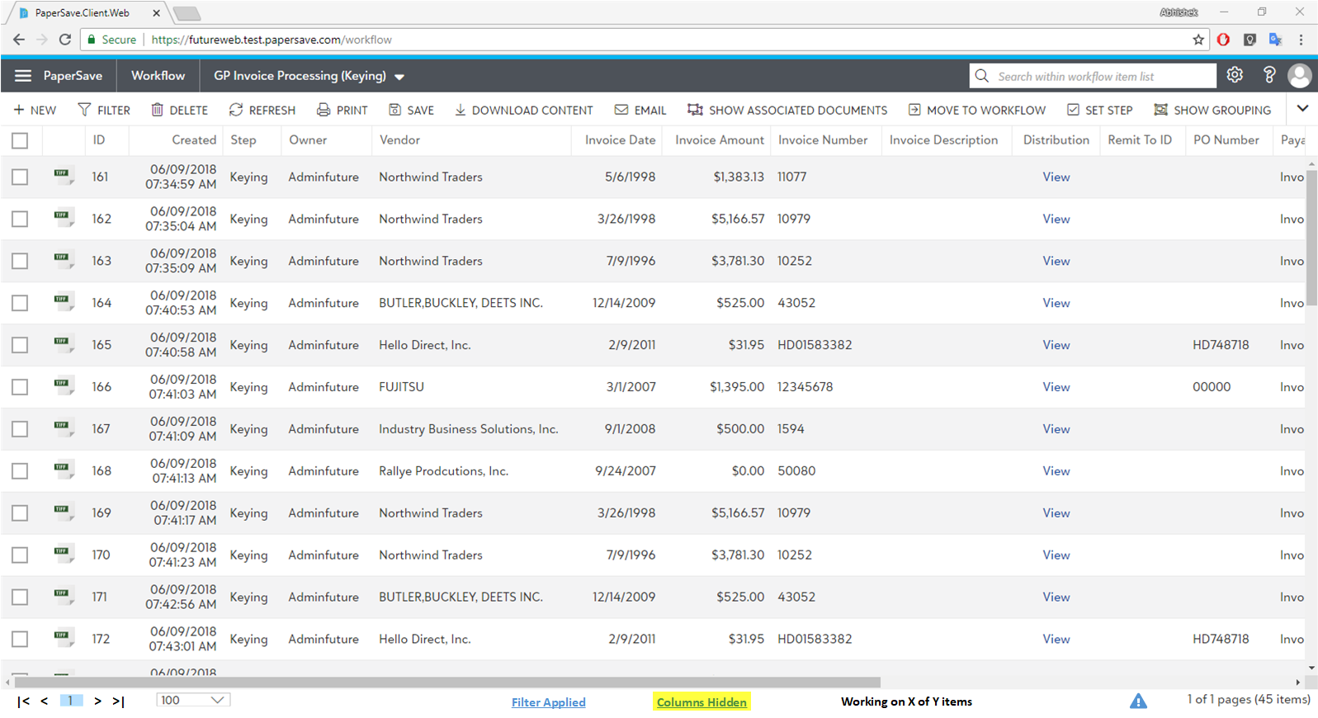

### Conditions:

#### Condition 1: Displaying “Columns Hidden” in the status bar

* *Using the “Set Columns” option, if the user has unchecked any of the columns from getting displayed, then it should display the “****Columns Hidden****” label in the status bar.*
  + *The text in the label should look like a hyperlink as shown in the mock up.*
* *In case, if the user checks all the columns to be displayed, then the “Columns Hidden” label should get disappear.*

#### Condition 2: Clicking on the “Columns Hidden” label

* *When the user clicks on the “****Columns Hidden****” label (which looks like a hyperlink), then it should open the same dialog box which opens up when the “Set Columns” option was selected.:*

#### Condition 3: Closing “Set Columns” dialog box

* *When the user closes the “Set Columns” dialog box and if all the columns are mark to be displayed, then it should remove the “Columns Hidden” label from the status bar.*
* *When the user closes the “Set Columns” dialog box and if one or some of the columns are mark to be hidden, then it should keep the “Columns Hidden” label in the status bar.*

### Acceptance Criteria:

#### Acceptance Criteria 1: Verifying Conditions

*Verify all the conditions mentioned above. (Condition 1 to 3)*

# User Story 6: Dynamic status of the Workflow Items

*As a workflow user I would like to know the status of the item(s) that I worked upon.*

### Mock Up:

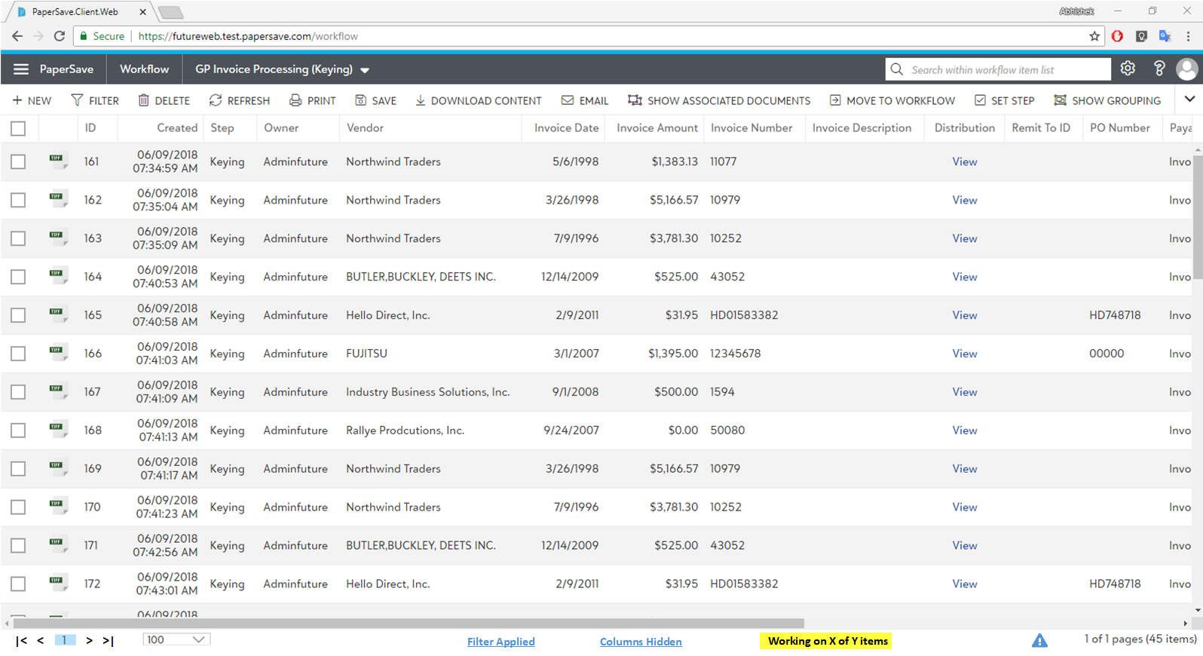

### Conditions:

#### Condition 1: Displaying “Working on X of Y items” in the status bar

* *In case, if the user is raising workflow events, moving items to another Workflow, Setting of Steps or Setting Owners on multiple workflow items, and the operations is taking a bit long time, let’s say more than 3 seconds, then in the status bar it should show a dynamic label stating “Working on X of Y items”, where X is the current item being worked upon and Y is the total number of Workflow items selected for the operation.*
* *The “X” here will keep on incrementing as it completes the operation per workflow item.*
* *Once “X” reaches “Y”, the label will remain as it is until the user:*
  + *Refreshes the Workflow App*
  + *Selects another set of workflow item(s)*

#### Condition 2: Performing same operation back to back

* Since operations like *raising workflow events, moving items to another Workflow, Setting of Steps or Setting Owners on multiple workflow items occurs asynchronously, then it is OK to raise the same operation again for n number of items together.*
* *For example, if workflow event is raised for 100 items and in the status bar it is showing currently as “Working on X of 100 items”, now user can select another 50 different items and should be able to perform the same operation which is raising workflow events in this example, then in the status bar the text should look like ‘Working on X of 150 items.’*
  + However, in this example the user cannot perform two different operations when one is already going on. For example, workflow event is raised for 100 items and while it is going on the user can perform another operation of the same type but cannot perform Move to another workflow operation or Setting step until the previous operation is completed.

### Acceptance Criteria:

#### Acceptance Criteria 1: Verifying Conditions

*Verify all the conditions mentioned above. (Condition 1 to 2)*

# User Story 7: Error Notification

*As a workflow user I would like to know the reason if any of the workflow items selected for submission failed with the help of an Error notification icon.*

### Mock Up:

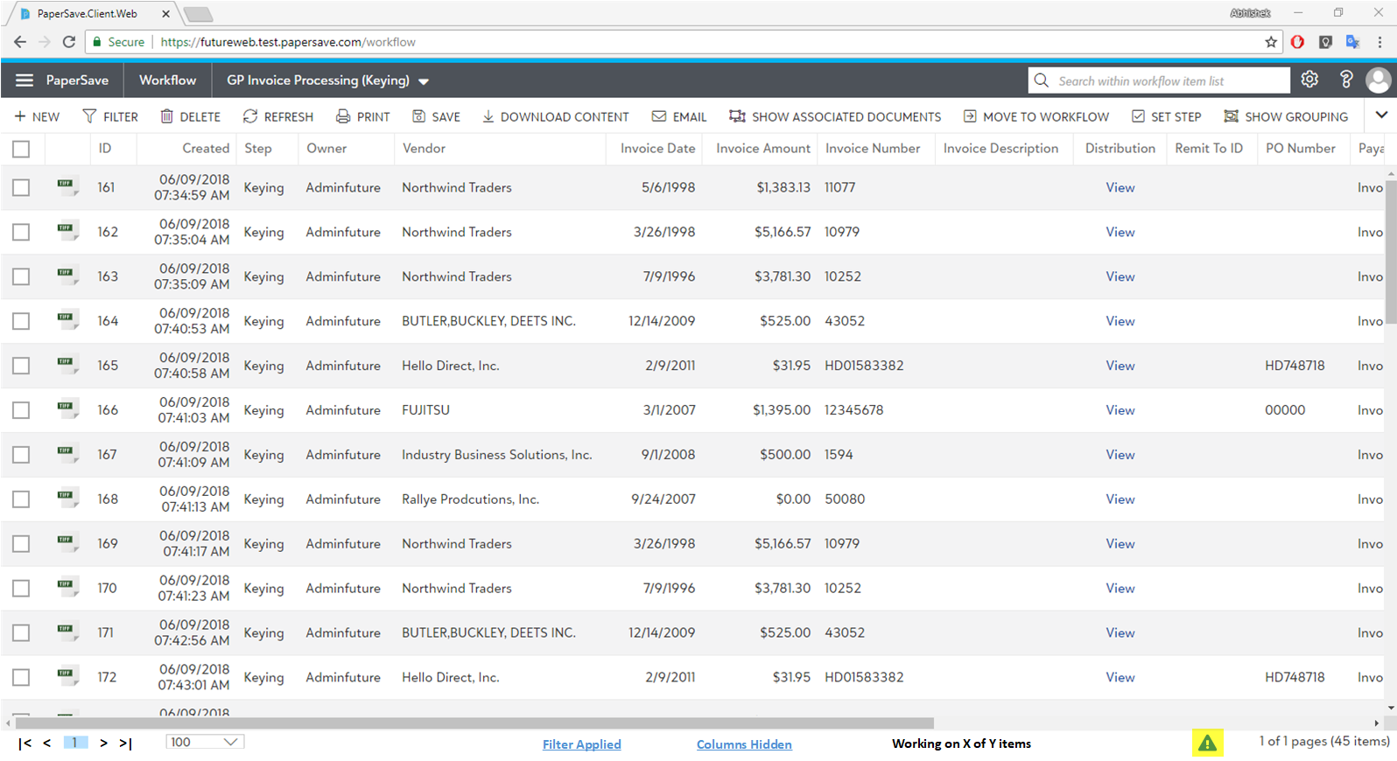

### Conditions:

#### Condition 1: Displaying “” icon n the status bar

* *When the user submits one or more Workflow Items, and in case one or more Workflow items failed to submit, then an icon “**” will be shown in the status bar of the workflow app.*

#### Condition 2: Clicking on the “” icon

* *The user should be able to click on the “**” icon (which looks like a hyperlink) when it appears.*
* *Upon clicking on the icon it should open a dialog box showing a grid as shown below:*



* ***Workflow Item ID:*** *column represents the Workflow Item ID which failed during the submission.*
* ***Error Details:*** *column represents the reason of its failure.*
* ***Clear All:*** *when clicked will clear all the current errors summary and will remove the “**” icon from the status bar.*
* ***Close or “X” or “Esc” key:*** *when clicked will close the Error Summary dialog box.*

### Acceptance Criteria:

#### Acceptance Criteria 1: Verifying Conditions

*Verify all the conditions mentioned above. (Condition 1 to 2)*

# User Story 8: Current of Total Pages & Total Items

*As a workflow user I would like to know total # of pages that exists for the currently workflow and also the total # of Workflow items exists for the selected workflow.*

### Mock Up:

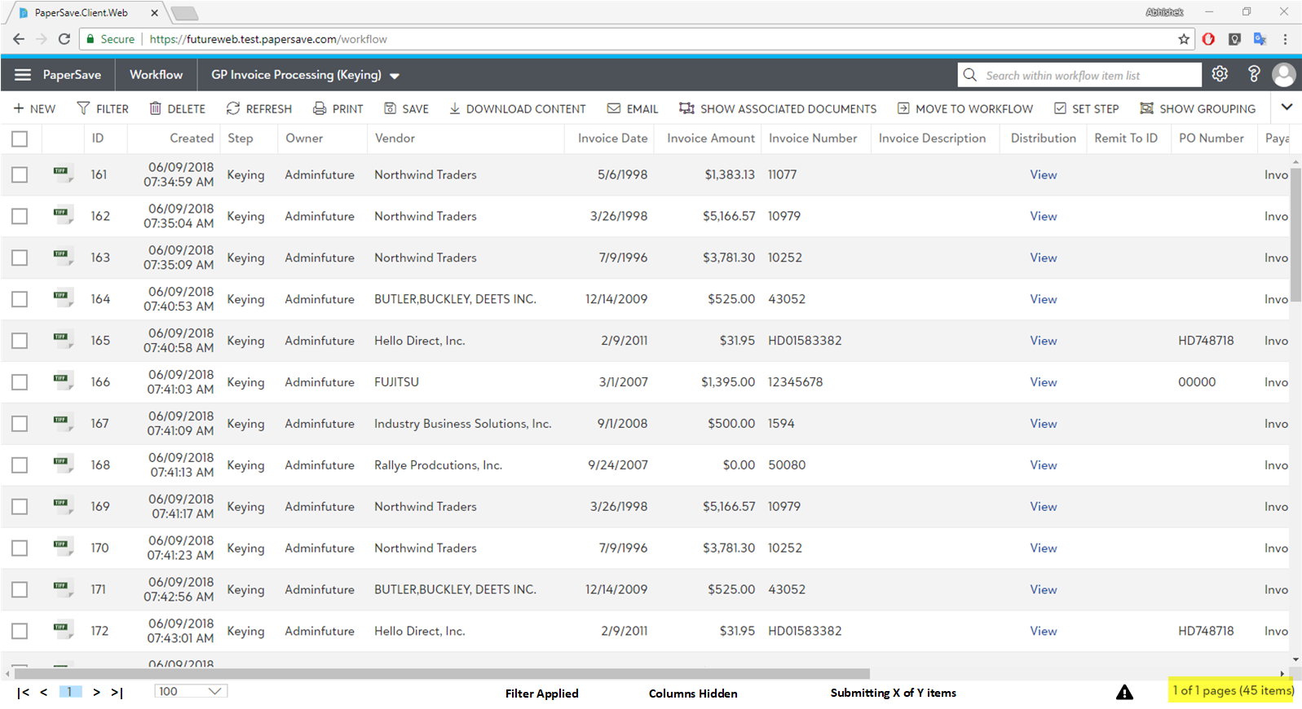

### Conditions:

#### Condition 1: Displaying “X of Y” pages

* *As highlighted in the mock up above, it must display current page the user is on as “X” and total number of pages that exists for the selected workflow as “of Y pages”. for example, if the total of the pages that exists are 11 and the user is currently on page # 3, then it should show it as “3 of 11 pages”.*
* *This label is also driven based on the value of the Page size, in case if page size is changed then the relative change should also update this label.*
* *This label is also driven based on the current page selected, in case if the current page is changed then the relative change should also update this label.*
* *This label should update its value when the Workflow app is refreshed and the result then is different before the refresh.*
* *This label should only appear if any workflow is selected.*

*.*

#### Condition 2: Display total # of Workflow Items

* *As highlighted in the mock up above, (45 items) represents the total number of workflow items that exists for the currently selected Workflow.*
* *This label should update its value when one or more workflow items were submitted successfully.*
* *This label should update its value when the Workflow app is refreshed and the result then is different before the refresh.*

### Acceptance Criteria:

#### Acceptance Criteria 1: Verifying Conditions

*Verify all the conditions mentioned above. (Condition 1 to 2)*